数据库设计文档 v1.0

1. 用户系统

1.1 users（用户表）
用途：存储用户基本信息和学习偏好
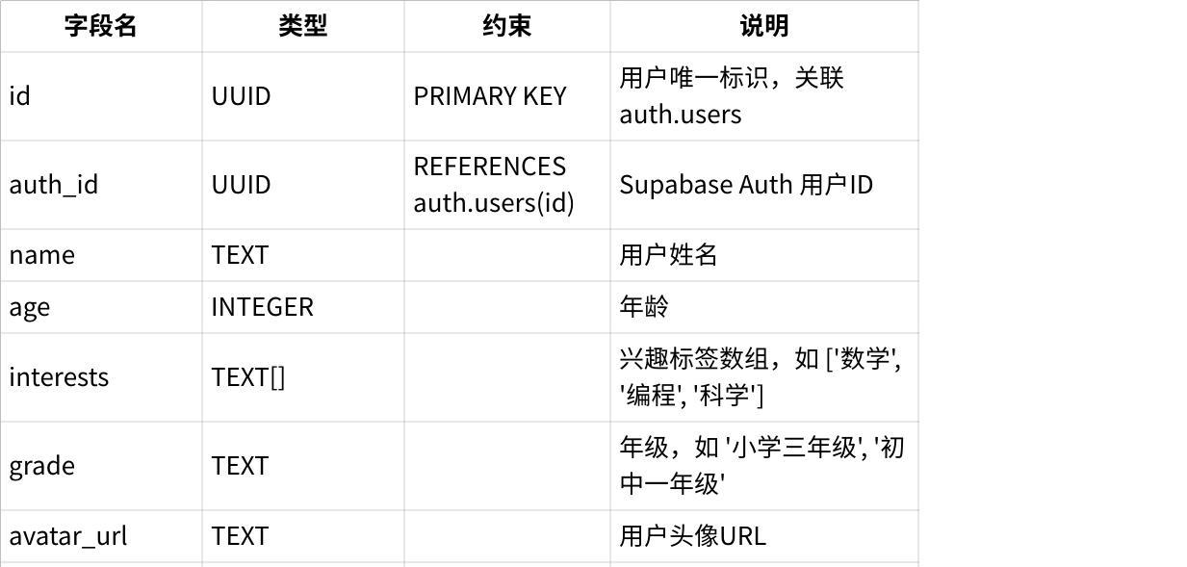
点击图片可查看完整电子表格
sql
SQL
CREATE TABLE users (
id UUID PRIMARY KEY DEFAULT uuid_generate_v4(),
auth_id UUID REFERENCES auth.users(id) UNIQUE,
name TEXT,
age INTEGER,
interests TEXT[],
grade TEXT,
avatar_url TEXT,
created_at TIMESTAMP DEFAULT NOW(),
updated_at TIMESTAMP DEFAULT NOW()
);

1.2 user_profile（用户画像表）
用途：存储长期记忆和用户学习行为关键信息
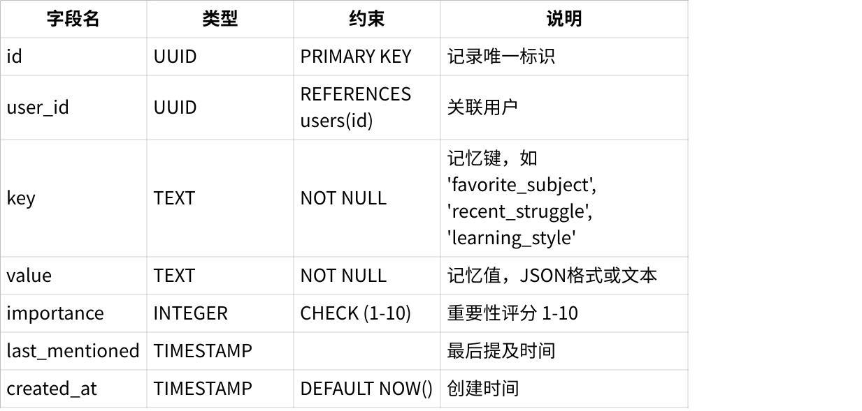
点击图片可查看完整电子表格

索引：
SQL
CREATE TABLE user_profile ( id UUID PRIMARY KEY DEFAULT uuid_generate_v4(), user_id UUID REFERENCES users(id) ON DELETE CASCADE, key TEXT NOT NULL, value TEXT NOT NULL, importance INTEGER CHECK (importance BETWEEN 1 AND 10), last_mentioned TIMESTAMP, created_at TIMESTAMP DEFAULT NOW() );
CREATE INDEX idx_profile_user ON user_profile(user_id);
CREATE INDEX idx_profile_key ON user_profile(user_id, key);
示例数据：
sql
SQL
INSERT INTO user_profile (user_id, key, value, importance) VALUES
('user-123', 'favorite_subject', '数学', 8),
('user-123', 'recent_struggle', '分数运算', 9),
('user-123', 'learning_style', '喜欢通过图形理解概念', 7);

2. 对话系统

2.1 conversations（对话会话表）
用途：管理用户与AI角色的对话会话
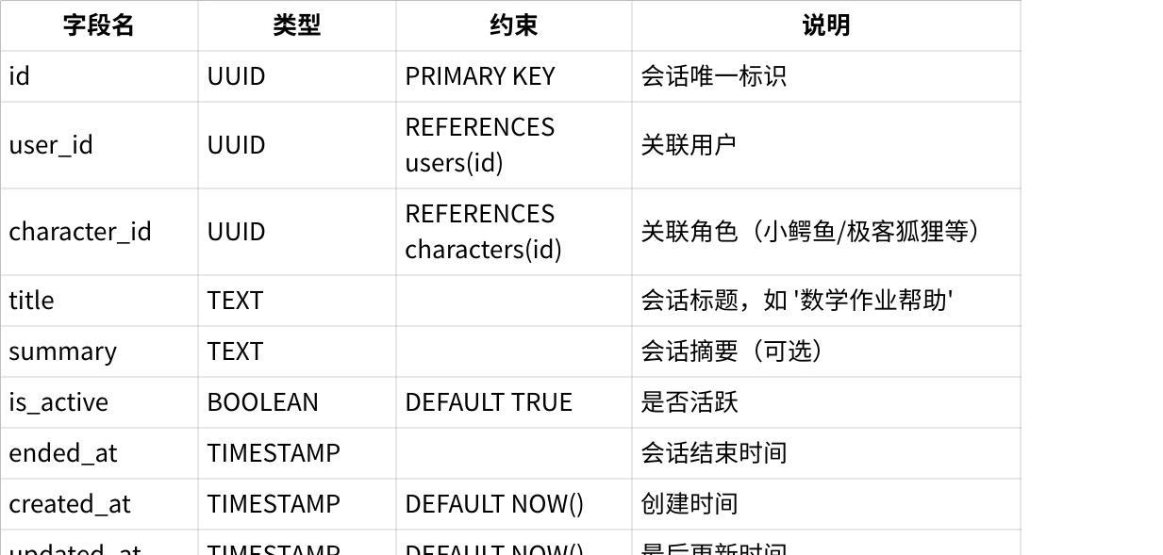
点击图片可查看完整电子表格
sql
SQL
CREATE TABLE conversations (
id UUID PRIMARY KEY DEFAULT uuid_generate_v4(),
user_id UUID REFERENCES users(id) ON DELETE CASCADE,
character_id UUID REFERENCES characters(id),
title TEXT,
summary TEXT,
is_active BOOLEAN DEFAULT TRUE,
ended_at TIMESTAMP,
created_at TIMESTAMP DEFAULT NOW(),
updated_at TIMESTAMP DEFAULT NOW()
);

2.2 messages（消息表）
用途：存储对话中的每条消息
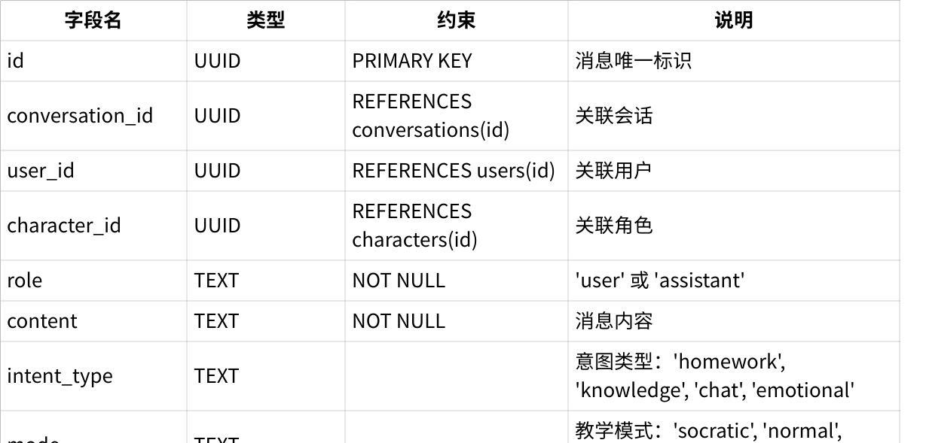
点击图片可查看完整电子表格
sql
SQL
CREATE TABLE messages (
id UUID PRIMARY KEY DEFAULT uuid_generate_v4(),
conversation_id UUID REFERENCES conversations(id) ON DELETE CASCADE,
user_id UUID REFERENCES users(id) ON DELETE CASCADE,
character_id UUID REFERENCES characters(id),
role TEXT NOT NULL CHECK (role IN ('user', 'assistant')),
content TEXT NOT NULL,
intent_type TEXT CHECK (intent_type IN ('homework', 'knowledge', 'chat', 'emotional')),
mode TEXT CHECK (mode IN ('socratic', 'normal', 'encourage')),
metadata JSONB,
tokens_used INTEGER,
created_at TIMESTAMP DEFAULT NOW()
);
索引：
sql
SQL
CREATE INDEX idx_messages_conversation ON messages(conversation_id);
CREATE INDEX idx_messages_user ON messages(user_id);
CREATE INDEX idx_messages_created ON messages(created_at DESC);

3. 角色系统

3.1 characters（对话角色表）
用途：存储AI角色配置（小鳄鱼、极客狐狸等）
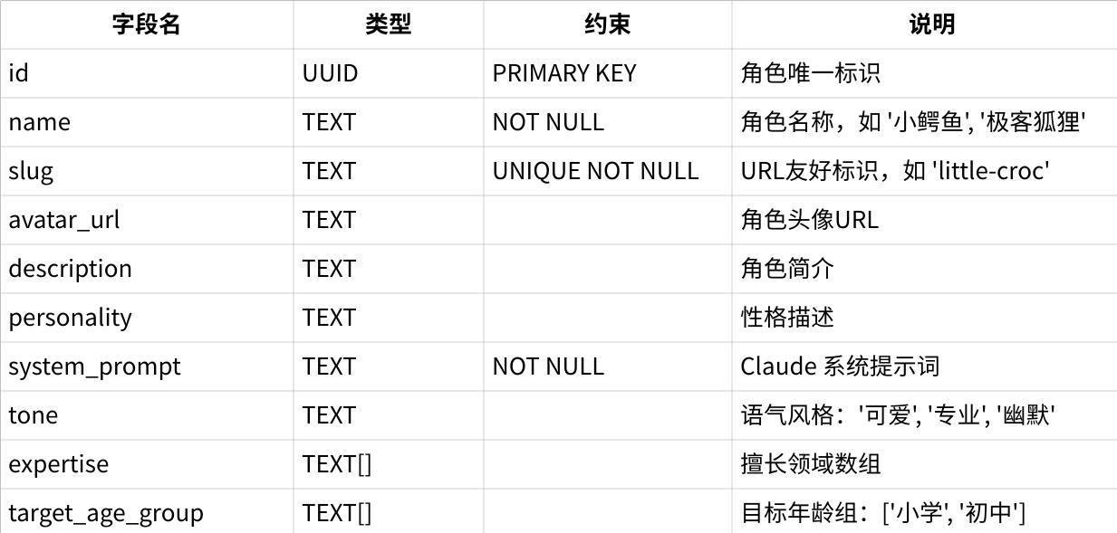
点击图片可查看完整电子表格
sql
SQL
CREATE TABLE characters (
id UUID PRIMARY KEY DEFAULT uuid_generate_v4(),
name TEXT NOT NULL,
slug TEXT UNIQUE NOT NULL,
avatar_url TEXT,
description TEXT,
personality TEXT,
system_prompt TEXT NOT NULL,
tone TEXT,
expertise TEXT[],
target_age_group TEXT[],
model TEXT DEFAULT 'claude-sonnet-4-20250514',
temperature FLOAT DEFAULT 0.7 CHECK (temperature >= 0 AND temperature <= 1),
max_tokens INTEGER DEFAULT 1000,
is_active BOOLEAN DEFAULT TRUE,
is_premium BOOLEAN DEFAULT FALSE,
sort_order INTEGER DEFAULT 0,
created_at TIMESTAMP DEFAULT NOW(),
updated_at TIMESTAMP DEFAULT NOW()
);
索引：
sql
SQL
CREATE INDEX idx_characters_active ON characters(is_active, sort_order);
CREATE INDEX idx_characters_slug ON characters(slug);

3.2 character_user_memories（角色用户记忆表）
用途：存储特定角色对特定用户的个性化记忆
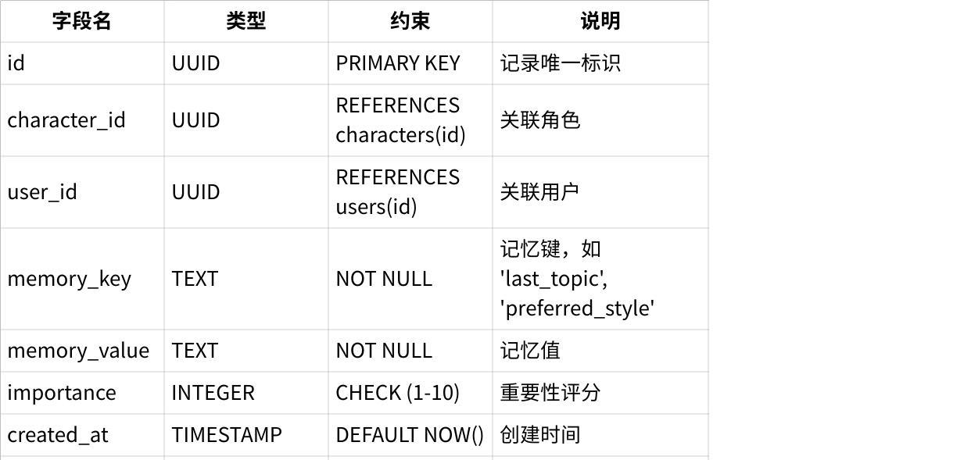
点击图片可查看完整电子表格
sql
SQL
CREATE TABLE character_user_memories (
id UUID PRIMARY KEY DEFAULT uuid_generate_v4(),
character_id UUID REFERENCES characters(id) ON DELETE CASCADE,
user_id UUID REFERENCES users(id) ON DELETE CASCADE,
memory_key TEXT NOT NULL,
memory_value TEXT NOT NULL,
importance INTEGER CHECK (importance BETWEEN 1 AND 10),
created_at TIMESTAMP DEFAULT NOW(),
updated_at TIMESTAMP DEFAULT NOW(),
UNIQUE(character_id, user_id, memory_key)
);
索引：
sql
SQL
CREATE INDEX idx_char_memories ON character_user_memories(character_id, user_id);

4. 播客推送系统

4.1 podcasts（播客内容表）
用途：存储每日生成的播客内容
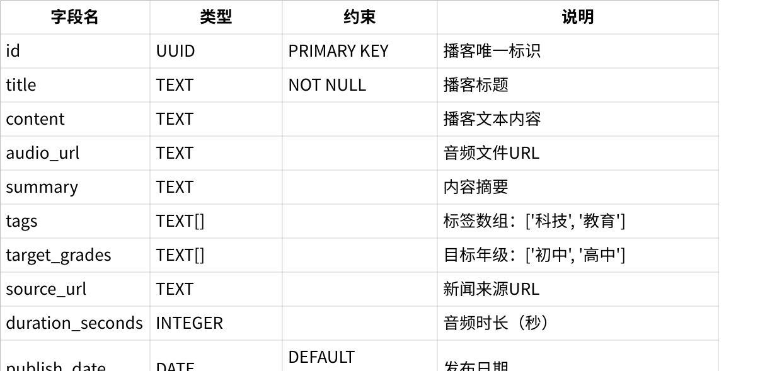
点击图片可查看完整电子表格
sql
SQL
CREATE TABLE podcasts (
id UUID PRIMARY KEY DEFAULT uuid_generate_v4(),
title TEXT NOT NULL,
content TEXT,
audio_url TEXT,
summary TEXT,
tags TEXT[],
target_grades TEXT[],
source_url TEXT,
duration_seconds INTEGER,
publish_date DATE DEFAULT CURRENT_DATE,
is_published BOOLEAN DEFAULT FALSE,
created_at TIMESTAMP DEFAULT NOW()
);
索引：
sql
SQL
CREATE INDEX idx_podcasts_date ON podcasts(publish_date DESC);
CREATE INDEX idx_podcasts_published ON podcasts(is_published, publish_date);

4.2 user_podcast_feeds（用户播客推送记录表）
用途：记录推送给用户的播客
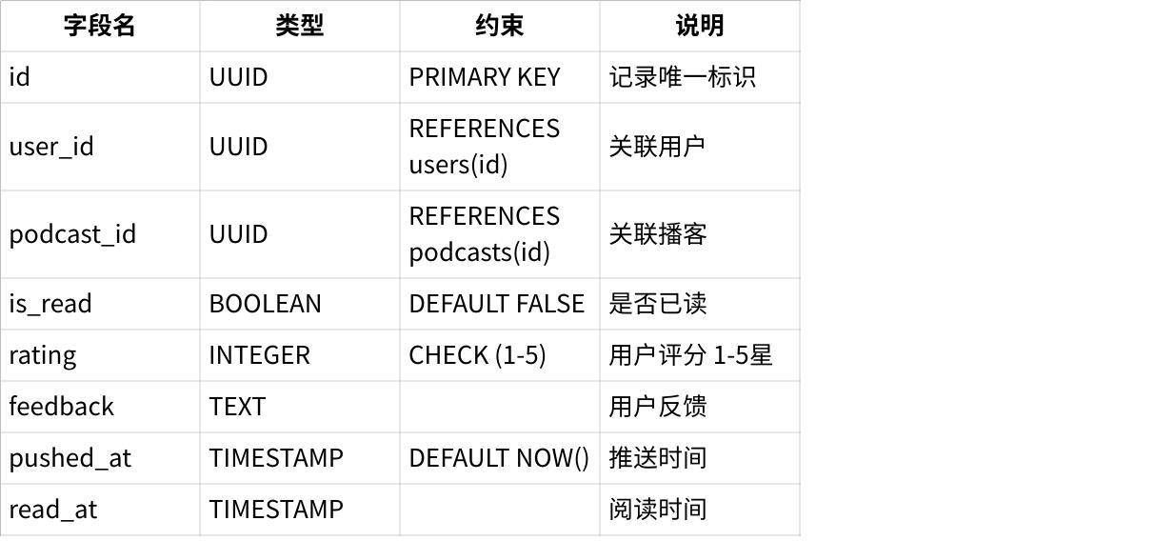
点击图片可查看完整电子表格
sql
SQL
CREATE TABLE user_podcast_feeds (
id UUID PRIMARY KEY DEFAULT uuid_generate_v4(),
user_id UUID REFERENCES users(id) ON DELETE CASCADE,
podcast_id UUID REFERENCES podcasts(id) ON DELETE CASCADE,
is_read BOOLEAN DEFAULT FALSE,
rating INTEGER CHECK (rating BETWEEN 1 AND 5),
feedback TEXT,
pushed_at TIMESTAMP DEFAULT NOW(),
read_at TIMESTAMP,
UNIQUE(user_id, podcast_id)
);
索引：
sql
SQL
CREATE INDEX idx_feeds_user ON user_podcast_feeds(user_id);
CREATE INDEX idx_feeds_unread ON user_podcast_feeds(user_id, is_read);

4.3 user_podcast_preferences（用户播客偏好表）
用途：存储用户播客订阅偏好
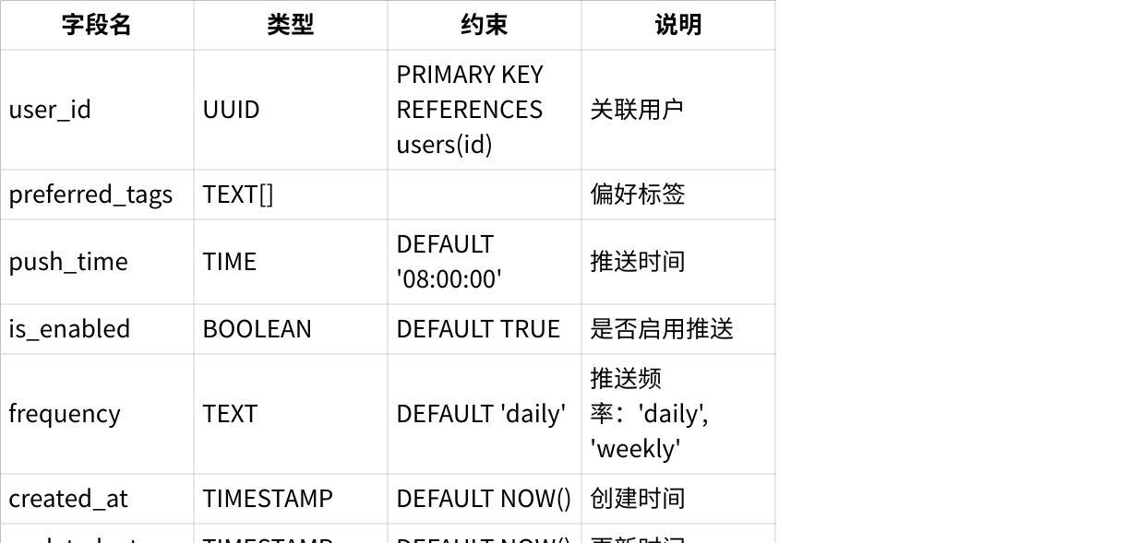
点击图片可查看完整电子表格
sql
SQL
CREATE TABLE user_podcast_preferences (
user_id UUID PRIMARY KEY REFERENCES users(id) ON DELETE CASCADE,
preferred_tags TEXT[],
push_time TIME DEFAULT '08:00:00',
is_enabled BOOLEAN DEFAULT TRUE,
frequency TEXT DEFAULT 'daily' CHECK (frequency IN ('daily', 'weekly', 'custom')),
created_at TIMESTAMP DEFAULT NOW(),
updated_at TIMESTAMP DEFAULT NOW()
);

5. ER图
SQL
```
---
## 8. ER 图
### 8.1 实体关系概览
```
┌─────────────┐
│ auth.users │
│ (Supabase) │
└──────┬──────┘
│ 1:1
▼
┌─────────────┐ ┌──────────────────┐
│ users │────────▶│ user_profile │
│ │ 1:N │ (长期记忆) │
└──────┬──────┘ └──────────────────┘
│ 1:N
▼
┌─────────────────┐ ┌──────────────────┐
│ conversations │────▶│ messages │
│ │ 1:N │ │
└────────┬────────┘ └──────────────────┘
│
│ N:1
▼
┌─────────────────┐ ┌──────────────────────────┐
│ characters │────▶│ character_user_memories │
│ (角色配置) │ 1:N │ (角色记忆) │
└─────────────────┘ └──────────────────────────┘
┌─────────────┐ ┌──────────────────────┐
│ podcasts │────────▶│ user_podcast_feeds │
│ │ 1:N │ │
└─────────────┘ └──────────────────────┘
▲
│ N:1
┌────────┴────────┐
│ user_podcast_ │
│ preferences │
└─────────────────┘

5.2 关系说明
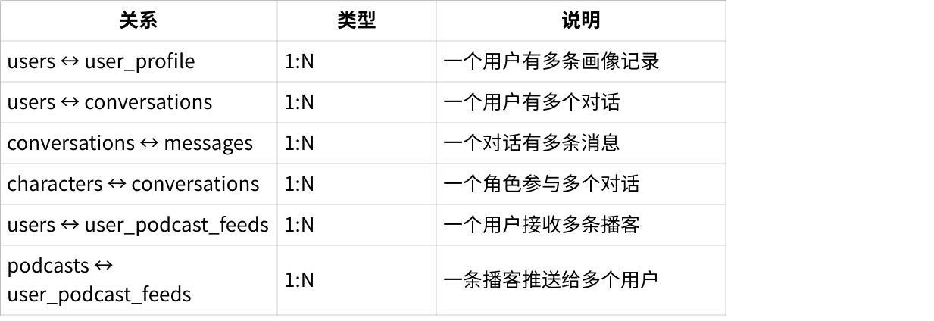
点击图片可查看完整电子表格

6. 初始化脚本

6.1 完整建表脚本
SQL
-- =============================================
-- 教育AI助手数据库初始化脚本
-- Version: 1.0
-- Date: 2025-01-05
-- =============================================
-- 启用 UUID 扩展
CREATE EXTENSION IF NOT EXISTS "uuid-ossp";
-- ============ 1. 用户系统 ============
CREATE TABLE users (
id UUID PRIMARY KEY DEFAULT uuid_generate_v4(),
auth_id UUID REFERENCES auth.users(id) UNIQUE,
name TEXT,
age INTEGER,
interests TEXT[],
grade TEXT,
avatar_url TEXT,
created_at TIMESTAMP DEFAULT NOW(),
updated_at TIMESTAMP DEFAULT NOW()
);
CREATE TABLE user_profile (
id UUID PRIMARY KEY DEFAULT uuid_generate_v4(),
user_id UUID REFERENCES users(id) ON DELETE CASCADE,
key TEXT NOT NULL,
value TEXT NOT NULL,
importance INTEGER CHECK (importance BETWEEN 1 AND 10),
last_mentioned TIMESTAMP,
created_at TIMESTAMP DEFAULT NOW()
);
-- ============ 2. 角色系统 ============
CREATE TABLE characters (
id UUID PRIMARY KEY DEFAULT uuid_generate_v4(),
name TEXT NOT NULL,
slug TEXT UNIQUE NOT NULL,
avatar_url TEXT,
description TEXT,
personality TEXT,
system_prompt TEXT NOT NULL,
tone TEXT,
expertise TEXT[],
target_age_group TEXT[],
model TEXT DEFAULT 'claude-sonnet-4-20250514',
temperature FLOAT DEFAULT 0.7 CHECK (temperature >= 0 AND temperature <= 1),
max_tokens INTEGER DEFAULT 1000,
is_active BOOLEAN DEFAULT TRUE,
is_premium BOOLEAN DEFAULT FALSE,
sort_order INTEGER DEFAULT 0,
created_at TIMESTAMP DEFAULT NOW(),
updated_at TIMESTAMP DEFAULT NOW()
);
CREATE TABLE character_user_memories (
id UUID PRIMARY KEY DEFAULT uuid_generate_v4(),
character_id UUID REFERENCES characters(id) ON DELETE CASCADE,
user_id UUID REFERENCES users(id) ON DELETE CASCADE,
memory_key TEXT NOT NULL,
memory_value TEXT NOT NULL,
importance INTEGER CHECK (importance BETWEEN 1 AND 10),
created_at TIMESTAMP DEFAULT NOW(),
updated_at TIMESTAMP DEFAULT NOW(),
UNIQUE(character_id, user_id, memory_key)
);
-- ============ 3. 对话系统 ============
CREATE TABLE conversations (
id UUID PRIMARY KEY DEFAULT uuid_generate_v4(),
user_id UUID REFERENCES users(id) ON DELETE CASCADE,
character_id UUID REFERENCES characters(id),
title TEXT,
summary TEXT,
is_active BOOLEAN DEFAULT TRUE,
ended_at TIMESTAMP,
created_at TIMESTAMP DEFAULT NOW(),
updated_at TIMESTAMP DEFAULT NOW()
);
CREATE TABLE messages (
id UUID PRIMARY KEY DEFAULT uuid_generate_v4(),
conversation_id UUID REFERENCES conversations(id) ON DELETE CASCADE,
user_id UUID REFERENCES users(id) ON DELETE CASCADE,
character_id UUID REFERENCES characters(id),
role TEXT NOT NULL CHECK (role IN ('user', 'assistant')),
content TEXT NOT NULL,
intent_type TEXT CHECK (intent_type IN ('homework', 'knowledge', 'chat', 'emotional')),
mode TEXT CHECK (mode IN ('socratic', 'normal', 'encourage')),
metadata JSONB,
tokens_used INTEGER,
created_at TIMESTAMP DEFAULT NOW()
);
-- ============ 4. 播客系统 ============
CREATE TABLE podcasts (
id UUID PRIMARY KEY DEFAULT uuid_generate_v4(),
title TEXT NOT NULL,
content TEXT,
audio_url TEXT,
summary TEXT,
tags TEXT[],
target_grades TEXT[],
source_url TEXT,
duration_seconds INTEGER,
publish_date DATE DEFAULT CURRENT_DATE,
is_published BOOLEAN DEFAULT FALSE,
created_at TIMESTAMP DEFAULT NOW()
);
CREATE TABLE user_podcast_feeds (
id UUID PRIMARY KEY DEFAULT uuid_generate_v4(),
user_id UUID REFERENCES users(id) ON DELETE CASCADE,
podcast_id UUID REFERENCES podcasts(id) ON DELETE CASCADE,
is_read BOOLEAN DEFAULT FALSE,
rating INTEGER CHECK (rating BETWEEN 1 AND 5),
feedback TEXT,
pushed_at TIMESTAMP DEFAULT NOW(),
read_at TIMESTAMP,
UNIQUE(user_id, podcast_id)
);
CREATE TABLE user_podcast_preferences (
user_id UUID PRIMARY KEY REFERENCES users(id) ON DELETE CASCADE,
preferred_tags TEXT[],
push_time TIME DEFAULT '08:00:00',
is_enabled BOOLEAN DEFAULT TRUE,
frequency TEXT DEFAULT 'daily' CHECK (frequency IN ('daily', 'weekly', 'custom')),
created_at TIMESTAMP DEFAULT NOW(),
updated_at TIMESTAMP DEFAULT NOW()
);
-- ============ 5. 创建索引 ============
-- 用户相关
CREATE INDEX idx_users_auth ON users(auth_id);
CREATE INDEX idx_profile_user ON user_profile(user_id);
CREATE INDEX idx_profile_key ON user_profile(user_id, key);
-- 角色相关
CREATE INDEX idx_characters_active ON characters(is_active, sort_order);
CREATE INDEX idx_characters_slug ON characters(slug);
CREATE INDEX idx_char_memories ON character_user_memories(character_id, user_id);
-- 对话相关
CREATE INDEX idx_conversations_user ON conversations(user_id);
CREATE INDEX idx_conversations_character ON conversations(character_id);
CREATE INDEX idx_conversations_active ON conversations(user_id, is_active);
CREATE INDEX idx_messages_conversation ON messages(conversation_id);
CREATE INDEX idx_messages_user ON messages(user_id);
CREATE INDEX idx_messages_created ON messages(created_at DESC);
-- 播客相关
CREATE INDEX idx_podcasts_date ON podcasts(publish_date DESC);
CREATE INDEX idx_podcasts_published ON podcasts(is_published, publish_date);
CREATE INDEX idx_feeds_user ON user_podcast_feeds(user_id);
CREATE INDEX idx_feeds_unread ON user_podcast_feeds(user_id, is_read);
-- ============ 6. Row Level Security ============
-- Users
ALTER TABLE users ENABLE ROW LEVEL SECURITY;
CREATE POLICY "Users can view own profile" ON users FOR SELECT USING (auth.uid() = auth_id);
CREATE POLICY "Users can update own profile" ON users FOR UPDATE USING (auth.uid() = auth_id);
-- Conversations
ALTER TABLE conversations ENABLE ROW LEVEL SECURITY;
CREATE POLICY "Users can view own conversations" ON conversations FOR SELECT
USING (auth.uid() = (SELECT auth_id FROM users WHERE id = user_id));
CREATE POLICY "Users can create conversations" ON conversations FOR INSERT
WITH CHECK (auth.uid() = (SELECT auth_id FROM users WHERE id = user_id));
-- Messages
ALTER TABLE messages ENABLE ROW LEVEL SECURITY;
CREATE POLICY "Users can view own messages" ON messages FOR SELECT
USING (auth.uid() = (SELECT auth_id FROM users WHERE id = user

